What we learn

1. Introduction of eclipse IDE
2. Java perspectives
3. Debugging of java program
4. Installation of Java Enterprise edition – for java web applications

<https://www.eclipse.org/downloads/packages/release/2020-03/r/eclipse-ide-enterprise-java-developers-includes-incubating-components>

1. Apache Tomcat server installation

<https://tomcat.apache.org/download-80.cgi>

1. How to make the web application – html files
2. How to configure Tomcat server ,setting of port number or changing of port number .

Operation

1. **Changing the file or class name** –

Right click on file 🡪refacter 🡪rename



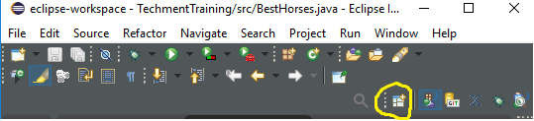

Goto right side and select the icon -🡪open perspective🡪change accordingly .

3.for debugging

Go open perspective -🡪select debug

Select the line which you want to edit by double click then save the file -🡪

Right click 🡪select run as debug 🡪use fn+f6 for see values .

1. For web application 🡪install java enterprise edition JEE

Then go to file -🡪new 🡪dynamic web project -🡪 project name 🡪next click 🡪next-🡪select check box to create --🡪 web.xml

Right click on web content folder and make new html 🡪index.html

After set the server and run it

1. For changing port number –

Servers-🡪select the tomcat -🡪server.xml -🡪source

Select cursor on first line-🡪ctrl+f

Now find and replace